Week 7 – Webinar B

In this webinar session, we will look at both of the collections introduced in this week’s lecture – arrays and ArrayLists.

# Learning Objectives

* **Employ** refactoring techniques to improve the readability of our programs
* **Develop** programs with multiple instances of the same class via the Array and ArrayList classes

# Preparation

Download and extract **Game.zip**. Open **Game.pde** and run the application. You should see a player-controlled plane and two yellow birds which fly across the screen (Figure 1). If either of the birds crash into the plane, the game stops. We will inspect the code together and go through each of the classes.

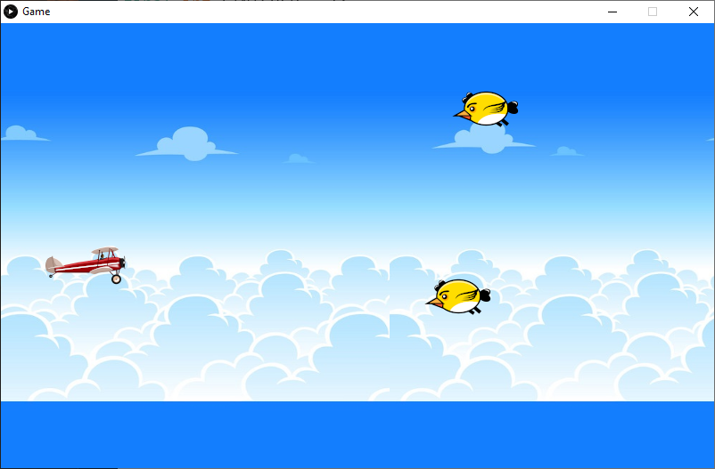

Figure - Game Output

# Step 1 – Refactoring

After going through each tab, we will refactor some of the code to improve the readability. Processing has some built-in refactoring tools (e.g. renaming methods and variables within a program) that we will look at.

# Step 2 – Implementing an Array of PImages

You will notice that the Bird class has four **PImage** variables for each image that the render method cycles through. Instead of having four variables to represent four individual images, we can have an array of PImages and then cycle through the array’s elements when animating the bird.

# Step 3 – Collection of Objects

We are now going to implement a collection of bird objects. Although we could declare and instantiate many objects of the same class and individually call their methods, using a *collection* in conjunction with *loops* allows us to streamline the process.

The code below creates an ArrayList capable of ‘storing’ Bird objects. An ArrayList is empty initially, and we can then add or remove objects as the program is running.

ArrayList<Bird> birdList = new ArrayList<Bird>();

birdList is an object of the ArrayList class – a built-in class for managing collections of *things*. We can add something to an ArrayList by calling the **add** method, and we can remove objects by calling the **remove** method.

We could manually add the objects we already have to this list or use some sort of rule to determine when to add a new bird to the list.